Thank you for choosing to enrol with Conifer Gardens Medical Centre.

Please read and complete these final forms so we can complete your enrolment.

Enrolment Procedure / Checklist
Updated 23/7/2020

 |  | √
1. | Complete an online Enrolment Form and a Medical Questionnaire for each person who is enrolling over the age of 1 year. Email the Medical Questionnaire separately back to the surgery cgmc@cgmc.co.nz once you have submitted your enrolment forms
2. | Upload a photo of a birth certificate or passport for each person enrolling
3. | Once you are enrolled you will be able to make an appointment with a GP.  When your notes from your previous GP are received our nurse will contact you by phone and talk to you about your medical questionnaire. This will incur a nurse consult fee, free if under 14.

To our valued patient

Our goal is to provide you with a satisfying, quality, caring and thorough assessment during your consultation.

The message we are receiving from our weekly patient survey is that patient satisfaction with our service is being hindered by the waiting times experienced within our practice.

In order to give everyone who wants to see a doctor or nurse a fair amount of time and to reduce waiting time for all, we would like to remind all of our patients that the standard appointment is for 15 minutes - it is usually only possible for the doctor or nurse to deal with one problem (health concern) in that time.

If you think you will need more than the standard 15 minute appointment (eg your concern is complicated), or if you have several problems to discuss, please book a double appointment (this will incur an extra fee).

During your consultation your doctor or nurse may advise you that your appointment has reached the end of its 15 minute timeframe. Your doctor or nurse may also advise you that you will need to make another appointment to cover all of your concerns – please do not be offended.

Thank you for your co-operation and understanding.

Kind regards
Conifer Gardens Medical Centre

Information for New Patients

In November 2018, Conifer Grove Medical Centre and Gardens Medical Centre merged to become Conifer Gardens Medical Centre.

The practice is part of Procare Network Manukau with Denis King, Peter Guy and Mark Wills (Omni Health) being the shareholders.

Conifer Gardens Medical Centre is committed to providing comprehensive, quality care to all of our patients. Our doctors and nurses are fully trained in general practice and we believe in supporting our patients’ health care, best managed by fostering a relationship that is caring and trusting.

GP Clinic Team
- Our Doctors
Dr Denis King Dr Lisa Stevenson Dr Peter Guy
Dr May Lim Dr Noela Dugu
We often have doctors for 6 month attachments gaining experience in working in a general practice.
- Our Practice Nurses
Yilin Yu (Lead Nurse)
Sarah De Lille (Practice Nurse)
Lian Kairua (Practice Nurse)
Jackie Appleby (Practice Nurse)
Nicola Leckie (Practice Nurse)
- Our Administration Staff
Carolyn Colmer (Reception)
Tracey Mead (Reception)
Kyle Els (Reception)
Barbara Duder (Reception)
Donna Parkinson (Practice Manager)

Opening Hours to see a GP or Nurse (by appointment)

Monday | Tuesday | Wednesday | Thursday | Friday
8.30am–5.00pm | 8.30am–5.00pm | 10.00am–7.00 pm | 8.30am–5.00pm | 8.30am–5.00pm

After Hours
If you are unwell or injured when we are closed, you can call our practice, free of charge, to speak to a nurse, phone 09 298 0238 – all calls are free from a landline. There are Accident & Medical clinics nearby and if you need them, they are funded at night, on weekends and public holidays to provide free or cheaper care for under 13’s and over 65’s. Your closest A&M’s are Counties Care, 6-18 O’Shannessey Street, Papakura, ph 09 299 9380 or, Takanini Care A&M, 106 Great South Road, Takanini, ph 09 299 7670.

In an emergency always call 111 or go to Middlemore Hospital Emergency Department.

Appointments & Cancellations
To see a doctor or a nurse you need to phone the practice to make an appointment or book your appointment via H365 (patient portal). If you are unable to attend an appointment, please phone the clinic at least one hour before so that we can offer this time to another patient. A fee may be charged if you miss an appointment without letting us know.

Consultations
Consultations with the Doctor are of 15 minutes duration. It is usually only possible to deal with one problem (health concern) per person in that time, perhaps two if they are straightforward. If you think you will need more time (eg your concern is complicated) or if you have several problems to discuss, please remember to book a double appointment (this will incur an extra fee). We hope to make the clinic schedule run smoothly to ensure that your waiting time is minimal and that you receive unrushed consideration of your problems.
138 Great South Road, Takanini, 2112… T 09 2980238… F 09 2977852… After Hours 09 2980238
HEALTHLINK EDI – congromc…Bank Account (BNZ): 02-0108-0327056-00

Prescriptions
There is a fee for prescriptions and an extra charge is added for same day prescriptions.

You can phone the practice and give the nurse information about your medication and the dosage or, if you are registered with Health365 (online portal) you can request your regular medication online.

Be as accurate as you can to reduce guesswork and errors. Sometimes you will need to be seen by the Doctor before they prescribe repeat medicines for you. If this is the case the nurse will let you know and arrange an appointment for you.

It is important that you do not run out of your medications (especially over long weekends and for holidays) – plan well ahead of time so that we can make the best arrangement for you to get a repeat script.

Same day prescription requests will be available for pickup after 4pm on the day of the request – you will need to phone this request in before 12 noon. Regular prescription requests will be available after 4pm on the day following the request.

Test Results
If your results for tests indicate that further action is required, a Practice Nurse will contact you. If you do not hear from us you can assume that there is no cause for concern or further action required. However, if you would like your result or you still are not better, please do not hesitate to phone the practice and ask to speak with the nurse.

Fees
Our practice fees are regulated by NZ government who provide subsidies for your healthcare.

There are separate charges for other procedures in the clinic such as minor surgical procedures & biopsies, ECG’s, liquid nitrogen, insurance & driver’s medicals, pregnancy testing, cervical smears, wound dressings and vaccinations etc- please ask at Reception for fees / charges.

Why we contact you by phone / text / email / letters
Conifer Gardens Medical Centre cares about working with you to improve your health. For this reason, there are several we contact you for.

This could be a reminder about screening tests you are due for like smears, mammograms, blood pressure checks or to let you know your child is due for their immunisation.

The clinic will also text / email you newsletters which will provide you with clinic updates and current health information that may be of use to you.

Please let us know if your contact details change as this will help us to communicate with you effectively and efficiently.

138 Great South Road, Takanini, 2112… T 09 2980238… F 09 2977852… After Hours 09 2980238
HEALTHLINK EDI – congromc…Bank Account (BNZ): 02-0108-0327056-00

NEW PATIENT Medical Questionnaire updated 15/4/19

Patient Name: | Patient DOB: | Date:

1. Do you have any, or have had any of the following medical conditions:
 | Self | Family |  | Self | Family
Diabetes | ⃝ Yes ⃝ No | ⃝ Yes ⃝ No | Blood clot/disorder | ⃝ Yes ⃝ No | ⃝ Yes ⃝ No
High Blood pressure | ⃝ Yes ⃝ No | ⃝ Yes ⃝ No | Stroke | ⃝ Yes ⃝ No | ⃝ Yes ⃝ No
Heart disease or circulation | ⃝ Yes ⃝ No | ⃝ Yes ⃝ No | High cholesterol | ⃝ Yes ⃝ No | ⃝ Yes ⃝ No
Heart Attack ⃝ <60yr ⃝ >60yr | ⃝ Yes ⃝ No | ⃝ Yes ⃝ No | Migraine | ⃝ Yes ⃝ No | ⃝ Yes ⃝ No
Asthma, lung or respirator | ⃝ Yes ⃝ No | ⃝ Yes ⃝ No | Epilepsy | ⃝ Yes ⃝ No | ⃝ Yes ⃝ No
Kidney disease | ⃝ Yes ⃝ No | ⃝ Yes ⃝ No | Cancer incl skin cancer | ⃝ Yes ⃝ No | ⃝ Yes ⃝ No
Liver disease or Hepatitis | ⃝ Yes ⃝ No | ⃝ Yes ⃝ No | Glaucoma | ⃝ Yes ⃝ No | ⃝ Yes ⃝ No
Bowel disease or problems | ⃝ Yes ⃝ No | ⃝ Yes ⃝ No | Rheumatic Fever | ⃝ Yes ⃝ No | ⃝ Yes ⃝ No
Joint disease or arthritis | ⃝ Yes ⃝ No | ⃝ Yes ⃝ No | Tuberculosis (TB) | ⃝ Yes ⃝ No | ⃝ Yes ⃝ No
Depression and/or anxiety | ⃝ Yes ⃝ No | ⃝ Yes ⃝ No | Eczema | ⃝ Yes ⃝ No | ⃝ Yes ⃝ No
Other mental health illnesses | ⃝ Yes ⃝ No | ⃝ Yes ⃝ No | Hay Fever | ⃝ Yes ⃝ No | ⃝ Yes ⃝ No

2. Do you have any other health, disability problems or inherited conditions? – please list
____________________________________________________________________________________________________

____________________________________________________________________________________________________

3. Please list any regular medications that you take:
____________________________________________________________________________________________________

____________________________________________________________________________________________________

4. Have you had any operations? ⃝ Yes (please list) ⃝ No
____________________________________________________________________________________________________

____________________________________________________________________________________________________

5. Are you allergic to anything, especially medications? ⃝ Yes (please list) ⃝ No
____________________________________________________________________________________________________

____________________________________________________________________________________________________

6. Do you drink alcohol? ⃝ Ye s ⃝ No If yes, on average, how much/week __________ And what type ______________

7. Do you have any substance abuse problems? ⃝ Yes ⃝ No

8. When was your last Tetanus booster? ________________________

9. Are your childhood immunisations up to date? ⃝ Yes ⃝ No ⃝ Don’t’ know

10. Women: (those over 20 years and sexually active)
When was your most recent cervical smear? _______________________

Have you ever had an abnormal smear? ⃝ Yes ⃝ No ⃝ Don’t know

Have you had a mammogram (those over 45 years)? ⃝ Yes ⃝ No If Yes, when? __________

11. Men: When was your last health check up? ________________________
NURSE TO COMPLETE
12. General Observation: Height:_____________ Weight: ____________ BP: _____________ Waist ____________
13. Is CVDRA appropriate? ⃝ Yes ⃝ No
14. Any extra bloods needed? ⃝ Yes ⃝ No
15. Book smear if due ⃝
16. Give mammogram booking information ⃝

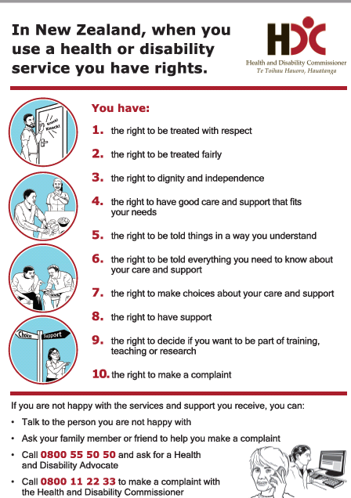

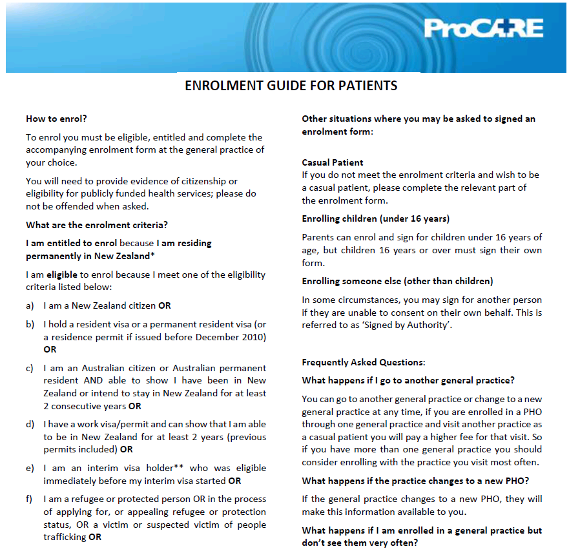

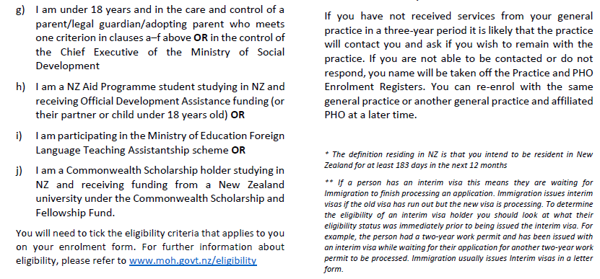

Downloaded from Procare 12/7/18

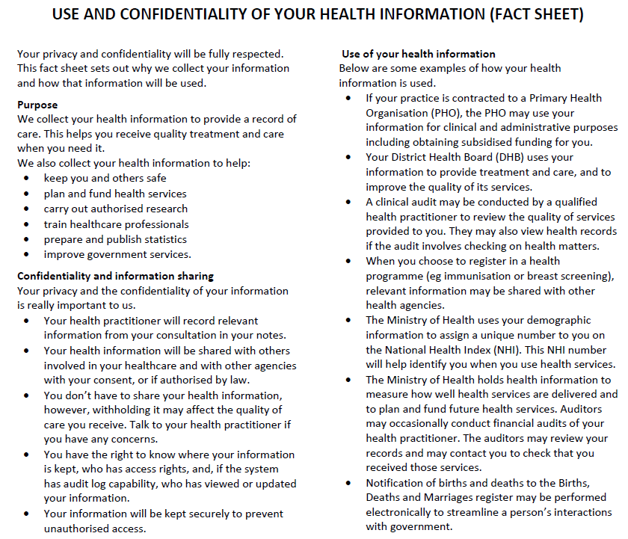

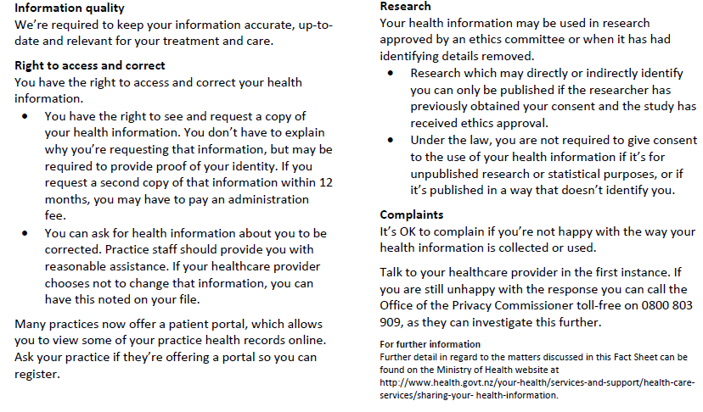
Downloaded from Procare 12/7/18
Downloaded from Procare 12/7/18

